# ZOUDIO AIO438

* **4 channel class-D amplifier**
* **Bluetooth V5.0 APT-X / A2DP / AAC**
* **Digital Signal Processor**
* **Windows™ configuration tool**
* **High power, high efficiency, low distortion**
* **Small footprint**

# Product description

High performance speaker building has never been easier. The ZOUDIO AIO438 combines all modern features in one easy to use and affordable module. The included wiring harness makes installation quick and reliable. The compact form factor allows for installation in nearly every speaker. Due to its high efficiency it puts out a lot more power than its size suggests. Besides long-range Bluetooth streaming, wired input is supported. The DSP allows for powerful filtering, in some cases replacing a big and expensive passive crossover altogether. Settings can easily be changed using the Windows™ configuration tool.

Direct product link (purchase, downloads, pictures): [www.zoudio.com/product/aio438](http://www.zoudio.com/product/aio438)

# Features

## Amplifiers

* 2x Texas Instruments **TAS5825M** (successor of the TPA3116/TPA3118 with lower distortion and built in DSP)
* Output power up to **4x 38W (4Ω)**, 2x 65W (2Ω) or 2x38W (4Ω) + 1x 65W (2Ω)
* Automatic **thermal foldback** and recovery for sustained power

## Connectivity

* **Bluetooth V5.0** APT-X / A2DP / AAC with onboard antenna
* **Optional external antenna** can be used (R34 must be removed to disconnect the onboard antenna)
* **Wired** analog input

## Power

* Wide range of accepted power supplies: **5 to 24V**
* **Low idle power** consumption, ideal for battery powered applications
* Programmable shutdown voltage and low power indication

## Settings

* **Input mixer** can be changed per 2 channels (left/right/mono)
* 8 general filters (**equalizers**) and 5 filters per channel (**crossovers**)
* 2 equalizers that can be toggled with the **EQ button** (e.g. indoor/outdoor, bass-boost)
* **Dynamic** (volume dependent) **equalizers**
* Programmable **delay** per channel
* Output configurable as **4.0 / 2.0 / 2.1**
* All settings can be changed using the **configuration tool for Windows™**, which can be downloaded via [www.zoudio.com/configtool](http://www.zoudio.com/configtool)
* **Advanced features are available for large orders** (>50 pieces). This includes, but is not limited to, custom Bluetooth name, modified firmware, limiters, special connectors/cables and pre-programmed boards.

# Specifications

|  |  |  |  |  |  |
| --- | --- | --- | --- | --- | --- |
| **Parameter** | **Min** | **Typ** | **Max** | **Unit** | **Notes** |
| Power supply voltage | 4.5 |  | 26.4 | Volts |  |
| Operating temperature | -10 |  | +70 | Celsius |  |
| BT range |  | 15 |  | Meters | Onboard antenna, line-of-sight |
| Analog input voltage |  |  | 2.0 | Volts | Single-ended |
| THD+N |  |  | 0.05 | % | 1KHz sine at 1W, 12V |
| Switching frequency |  | 768 |  | KHz | 1SPW modulation |
| Output power per channel (BTL) |  |  | 8 | Watt | 8R, 12V, 1% THD+N |
|  |  | 16 | Watt | 4R, 12V, 1% THD+N |
|  |  | 30 | Watt | 8R, 24V, 1% THD+N |
|  |  | 58 | Watt | 4R, 24V, 1% THD+N, thermally limited |
| Idle power |  | 79 |  | mA | 12V, all channels enabled |
|  | 88 |  | mA | 24V, all channels enabled |

# Connections

|  |  |
| --- | --- |
| **Power configuration** | **Recommended** |
|  | -12V 5A+  -19V 6A+  -24V 7A+ |
|  | -Sure BCPB2/BCPB3/BCPB4 |
|  | -6/12/18V lead-acid (24V not supported!)  -Protected lithium packs: 2-6S Li-Ion/Li-Po, 2-7S LiFePO4  *Note: board has no charging circuitry. CHG input is connected parallel to the PSU input for easy wiring of an external charger* |

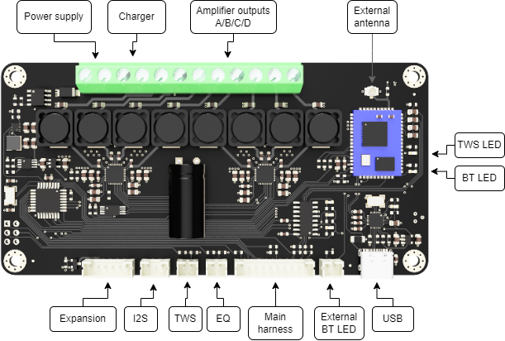

|  |  |
| --- | --- |
| **Name** | **Description** |
| Expansion | Reserved for future use |
| I2S | I2S header, contact Zoudio for details. |
| TWS | TrueWirelessStereo. Will be enabled in a future firmware update. |
| EQ | Toggles the last two equalizer filters. Will be enabled in a future firmware update. |
| Main harness | Contains:  - Power status LED: Red = low battery, Green = normal operation  - Volume knob: Short press = turn off/on, Long press = enter pairing  - Aux: 3.5mm analog input |
| BT LED | On = connected |
| USB | Connect to host PC |
| TWS | Reserved for future use |
| External antenna | U.FL connector for external antenna. If used, de-solder R34 to disconnect the onboard antenna. |

# Dimensions

-Height: 18 mm

# Disclaimers

* Wrong usage of this product will void your warranty
* For questions, remarks and/or custom orders please visit ZOUDIO.com and contact us

# Revisions

|  |  |  |
| --- | --- | --- |
| **Date** | **Revision** | **Change** |
| 7 nov 2021 | 0.1 | Document release |
| 4 apr 2022 | 0.2 | Update EQ filter amount  Update output power info  Add external antenna information  Add configtool link  Add connection diagram and table |